**Introduction:** **1**

**The Web Development Technology** **1**

Web Browser 2

Web Server 2

Frontend Development 2

Backend Development 2

Front End Development 2

# Introduction:

In this article, we will discuss and cover as much as we can about everything out there on the internet.

Have you ever been wondering what happens when you open up your browser and start searching for something on the internet?

Imagine you are shopping for something online, what is happening behind the scene from the first click you do on a link until you are finished surfing the web?

Or you just started your business and want to establish your first ever brand new website. How does it work?

# The Web Development Technology

The Web Development Technology contains two main parts, The Front End and The Back End.

The Front End is concerned with presentation and we all have experienced it daily on the internet. The Back End, on the other hand, is all other parts of the web that users do not directly interact with like the database, the web host or domain and dns servers.

Now let us get familiar with some of the technical terms in web development.

## 

## Web Browser

## Web Server

## Frontend Development

## Backend Development

A **Web Browser** is the platform that provides us with the tools we need to search on the internet (World Wide Web). Such as Google Chrome, Firefox, Safari, Microsoft edge.

The most popular and commonly used one is Google Chrome which has many helpful features for a beginner or an advanced web developer.

A **Web Server** is the program on a much more powerful computer that uses a certain type of a protocol on the internet to serve the users who are asking for a specific service.

## Front End Development

This is also known as “Client Side Development” which is the code and the interface that a user or a developer uses to create a website.

It is basically the written code for the website so this code needs a place to be stored on the internet to be reachable by other users and that is when a server comes in which is described and known as a backend development that handles different tasks such as Application Programming Interface and Databases.

**HTML:**

It is used to create electronic documents called web pages to be displayed on the World Wide Web. A block of text, a picture, a link that leads to another page, these are all created by HTML.

Without HTML, the browser would never know what and how to display for the user.

Computer Hope (2018)

**CSS ( Cascading Style Sheet ):**

Well, in a nutshell, CSS is the design and appearance of the website. The background colour, the text colours, the size and the position of the texts and the pictures in a website.

Without CSS, the website looks very plain and unpleasant for the viewers.

A successful website is the one with a nice CSS format which attracts more and more viewers.

IONOS Digitalguide. (n.d.)

**JavaScript:**

It is a lightweight scripting language which is commonly used alongside HTML and CSS by the web developers in order to create a dynamic website.

So, HTML is about the structure of a website, CSS is about the appearance of a website and JavaScript is about the functionality of a website and without one, the others cannot complete the job.

Hostinger Tutorials. (2021)

**Back End Development:**

Which is also known as Server Side Development, focuses on what happens behind the scene and is responsible for maintaining the quality and performance of the website.

Simply put, back end development refers to the process that the user cannot see.

Here are some of the tasks a web server does:

* Processing an incoming request
* Running a script (PHP, ASP, JSP, …) to generate HTML
* Accessing the data from a database by using SQL queries
* Storing and updating the data in a database
* Handling file uploads and downloads

Now let us answer the question “ How is a web page served? ”

You may or may not have heard of a DNS server. DNS stands for Domain Name Service which is basically a list of addresses for the websites on the internet.

In the human world, we address each other by names, but in the world of computers, the computers use and understand numbers only. DNS resolves names to numbers (IP addresses).

It works like a phonebook.

When you enter a URL of a website in your browser, the browser turns the URL into an IP address and sends a request to the DNS server asking for the address of that website. Then the DNS server will check its list for the address, sending the address back as a response to your browser, and then your browser will show you the website you asked for.

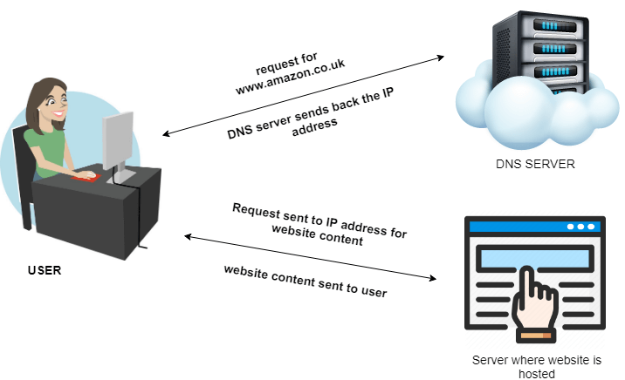

**Different types of DNS servers:**

There is a hierarchy for DNS from top to bottom which is:

* Root Level Domain
* Top Level Domain
* Second Level Domain
* Subdomains
* Hosts

www.thegeekdiary.com. (No Date)

Cloud Infrastructure Services. (2021)

**What is an IP address?**

Short for Internet Protocol which is a rule for devices on the internet to be connected together. The IP addresses are assigned by an ISP ( Internet Service Provider ) to the devices in order to communicate to each other on the internet.

An IP address consists of 4 octets. Each bit contains 8 bits so as a result IP addresses are 32 bits.

Simply put, having an IP address for a computer is like having identity and name for a person, so they can be recognised and have conversations with each other.

Here is an example of some IP address:

192.168.0.1

176.16.82.10

10.0.0.1

Kaspersky (2021)

**The differences between web server hardware, software and host operating**

**Systems:**

Web server hardwares are the computers that store the data about the specific website and deliver it when a user is asking for them.

A Web server software is the software that serves the web content either **static** or **dynamic** by using **“HTTP” protocol** which runs on a server and makes it into a web server such as **Apache** and **Microsoft IIS**.

The host operating systems are used by the web hosting companies. The most popular ones are Linux and Microsoft.

Digital.com. (No Date)

**What Are the advantages of an integrated database system with regards to expanding**

**website capability:**

An integrated database will help you manage a wide range of data for the users of your website and deliver a quicker service to them.

Naeem, T. (2019)

**What Are the common web development technologies and frameworks:**

The main scripting language for the web is JavaScript.

Angular: It is a rewrite of AngularJS which is a front-end mobile and web application framework developed by Google in 2010.

React: is an open-source, front-end JavaScript library which is used for creating an interactive UserInterface. It can be used for a single-page or a mobile application.

Django: It is an open-source framework for back-end applications based on python programming language which is one of the top web development languages.

www.orientsoftware.com. (No Date)

Django Stars Blog. (2016)

**Bibliography:**

Computer Hope (2018). *What is HTML (Hypertext Markup Language)?* [online] Computerhope.com. Available at: <https://www.computerhope.com/jargon/h/html.htm>.

IONOS Digitalguide. (n.d.). *This is a headline*. [online] Available at: <https://www.ionos.com/digitalguide/websites/web-design/what-is-css/>.

Hostinger Tutorials. (2021). *What Is JavaScript? A Basic Introduction to JS for Beginners*. [online] Available at: <https://www.hostinger.com/tutorials/what-is-javascript>.

www.thegeekdiary.com. (n.d.). *What are the Types of DNS Servers – The Geek Diary*. [online] Available at: <https://www.thegeekdiary.com/what-are-the-types-of-dns-servers/#:~:text=What%20are%20the%20Types%20of%20DNS%20Servers%201>

[Accessed 3 May 2022]

Cloud Infrastructure Services. (2021). *What is DNS Hierarchy Architecture with Examples (Explained)*. [online] Available at: <https://cloudinfrastructureservices.co.uk/what-is-dns-hierarchy/>

Kaspersky (2021). *What is an IP Address – Definition and Explanation*. [online] www.kaspersky.com. Available at: <https://www.kaspersky.com/resource-center/definitions/what-is-an-ip-address>.

Digital.com. (n.d.). *Web Servers Used in Web Hosting: Overview*. [online] Available at: <https://digital.com/best-web-hosting/web-servers/>.

Naeem, T. (2019). *Database Integration | Overview, Benefits, and Tools*. [online] Astera. Available at: <https://www.astera.com/type/blog/database-integration/>.

www.orientsoftware.com. (n.d.). *What technology should you use for Web Development?* [online] Available at: <https://www.orientsoftware.com/technologies/web-technologies/>.

Django Stars Blog. (2016). *Why We Use Django Framework & What Is Django Best Used For*. [online] Available at: <https://djangostars.com/blog/why-we-use-django-framework/>.